# Web App Design with React Week 1 Coding Assignment

**Points possible:** 70

|  |  |  |
| --- | --- | --- |
| Category | Criteria | % of Grade |
| Functionality | Does the code work? | 25 |
| Organization | Is the code clean and organized? Proper use of white space, syntax, and consistency are utilized. Names and comments are concise and clear. | 25 |
| Creativity | Student solved the problems presented in the assignment using creativity and out of the box thinking. | 25 |
| Completeness | All requirements of the assignment are complete. | 25 |

**Instructions:** In VS Code, or an IDE of your choice, write the code that accomplishes the objectives listed below. Ensure that the code compiles and runs as directed. Take screenshots of the code and of the running program (make sure to get screenshots of all required functionality) and paste them in this document where instructed below. Create a new repository on GitHub for this week’s assignments and push this document, with your JavaScript project code, to the repository. Add the URL for this week’s repository to this document where instructed and submit this document to your instructor when complete.

**Coding Steps:**

1. Using create-react-app, create a new React project.
2. Create a LoginForm component that should contain username and password input fields, an h3 that says Log In, and a border. Style the component using the default generated css file.
3. Create a Navigation component that contains links styled like a navbar. The links don’t have to go anywhere.
4. Put the Navigation component at the top of the page and the LoginForm in the center of the page.

**Screenshots of Code:**

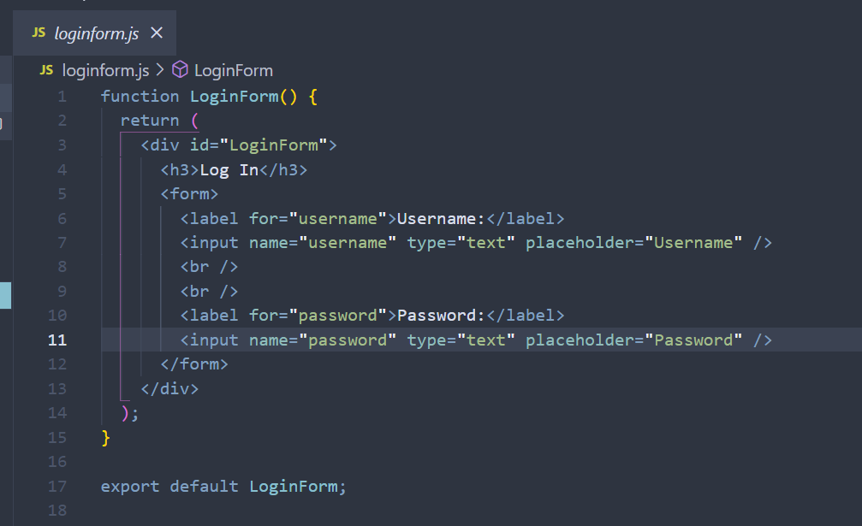

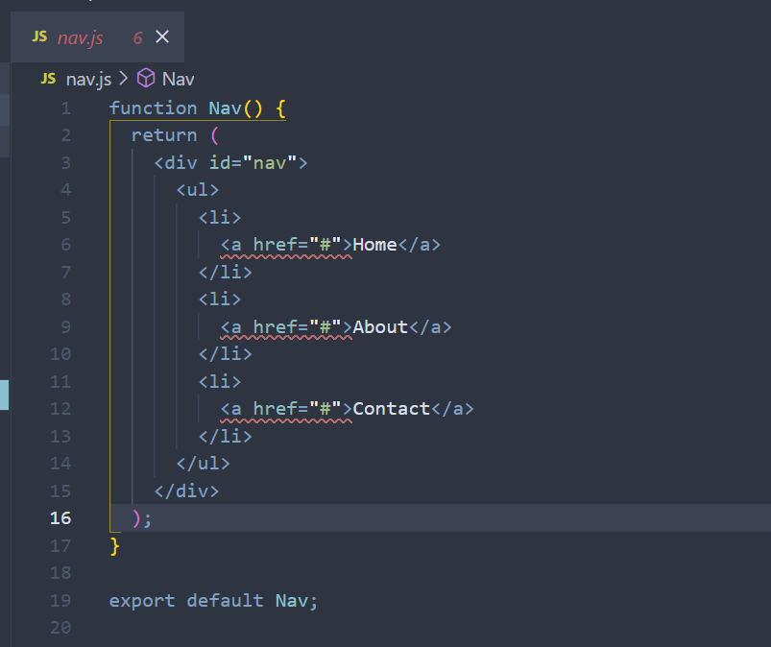

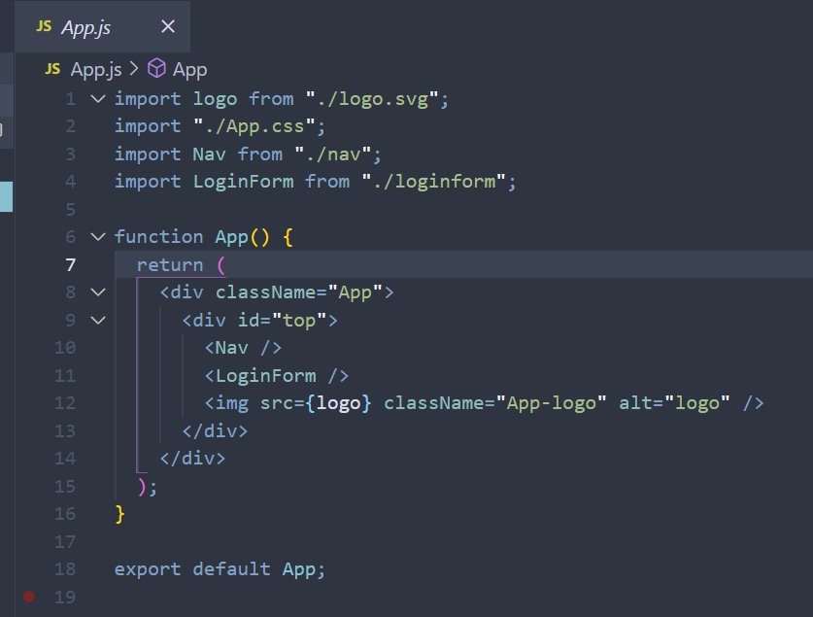

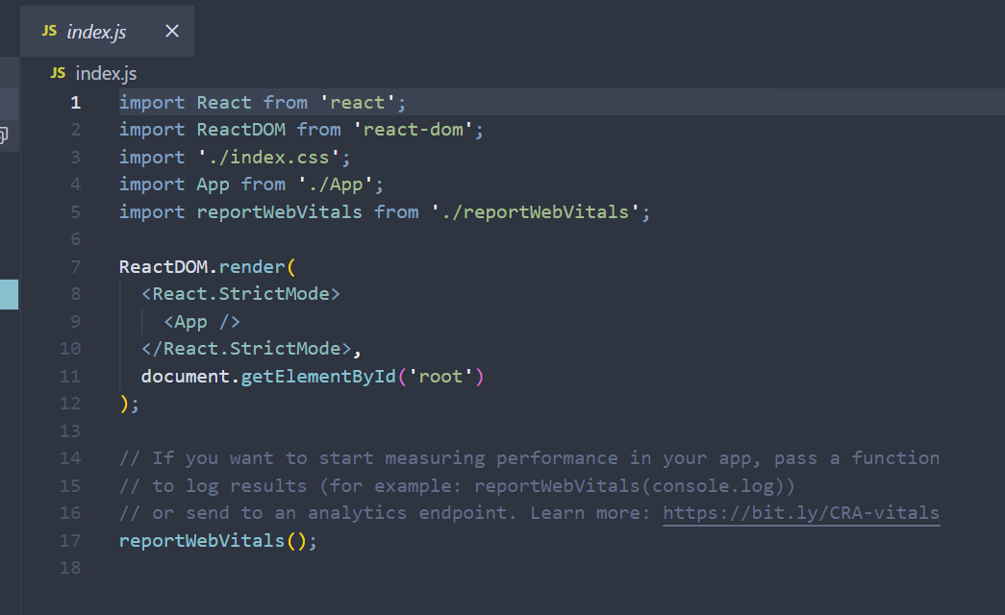

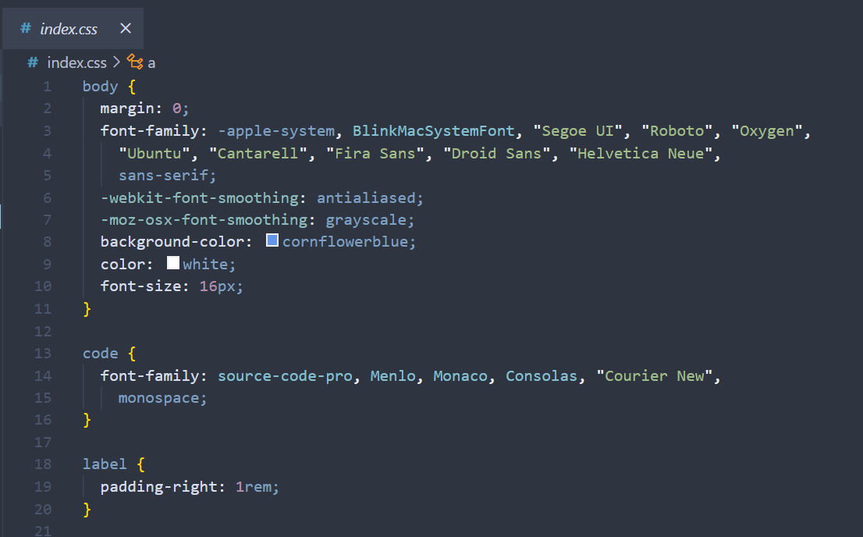

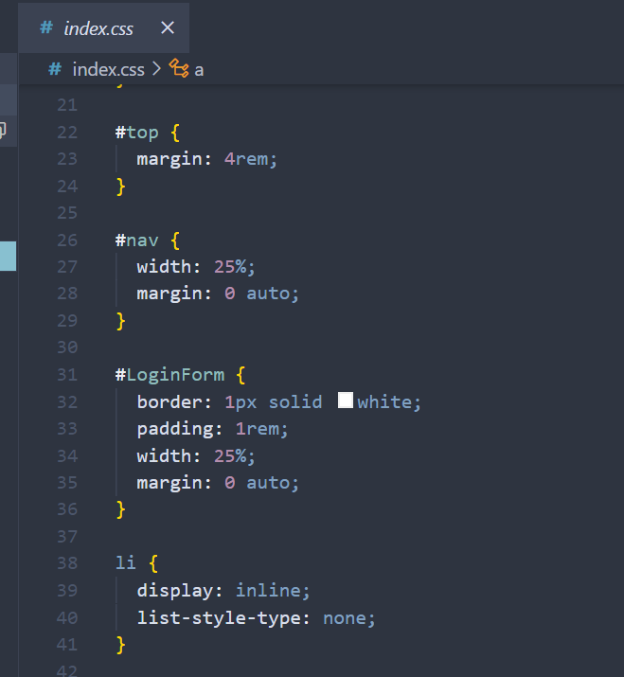

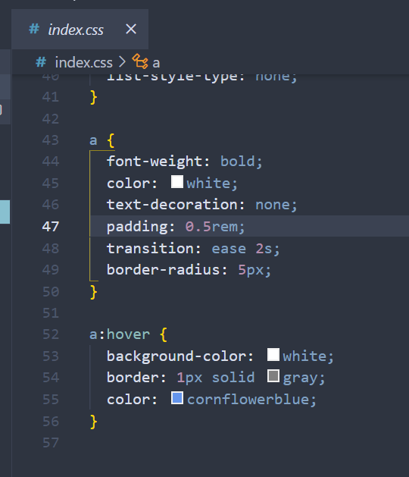

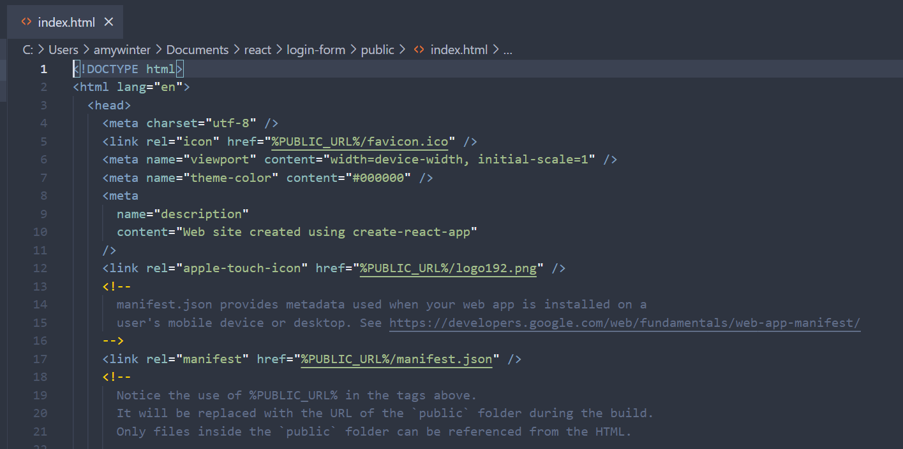

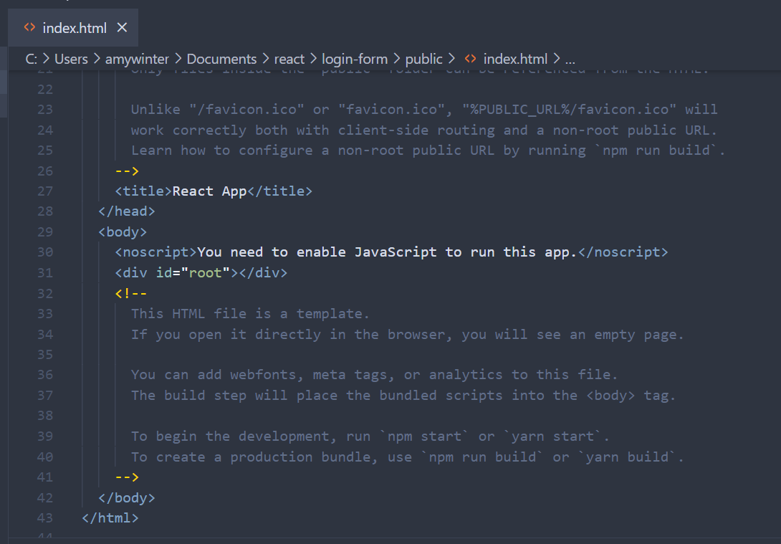

**Screenshots of Running Application:**

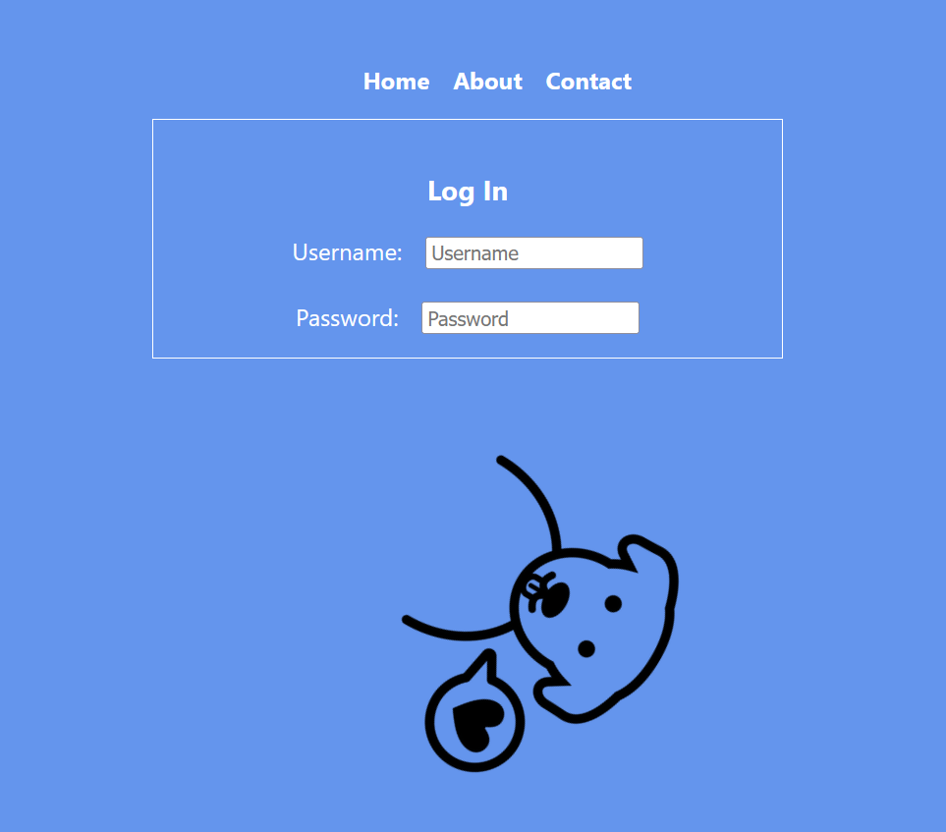

**URL to GitHub Repository:** [**https://github.com/amyewinter/PT-Reactwk1**](https://github.com/amyewinter/PT-Reactwk1)